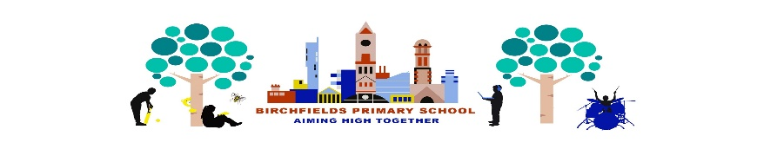

Birchfields Sport Clubs
Spring 1
Some sports clubs are starting up on the week beginning 11.1.21
Club letters can be found in the red sports post boxes in school after the school holiday.
Make sure a permission slip is filled in and returned to Miss Wall or placed in the red box outside 6EH or the PE cupboard
PE KIT MUST BE WORN
DUE TO COVID-19 RESTRICTIONS CLUB PLACES ARE RESTRICTED TO 16. ALL CHILDREN WILL BE FROM THE SAME BUBBLE.
Club | Morning  8.00-8.45  Meet in canteen | Lunchtime  12.45-1.30 | After School  3.15-4.00
Monday |  |  | Y5 Bubble, Badminton club
Tuesday |  |  | Y6 Bubble, Badminton club
Wednesday
Thursday |  |  | Y2 Bubble, multi-skills club
Friday |  | Boccia Y3&4 | Y4 Bubble, multi-sports club

